|  |  |
| --- | --- |
| **Student Name** | **Om Atul Mahadeokar** |
| **SRN No** | 202200340 |
| **Roll No** | 17 |
| **Program** | Computer Engg. |
| **Year** | Third Year |
| **Division** | B |
| **Subject** | Computer Network Laboratory (BTECCE21506) |
| **Assignment No** | 1 |

Assignment Number - 03

**Title:** Subnetting and Super netting in Computer Network

**Problem Statement** Using a Network Simulator (e.g. packet tracer) Configure subnetting and super netting.

**Theory:**

**Subnetting**

Subnetting is a technique used in computer networking to divide a larger IP network into smaller, more manageable sub-networks or subnets. It's a fundamental concept in IP addressing and is used to efficiently allocate IP addresses and manage network resources. Subnetting allows network administrators to create logical divisions within a larger network, helping to improve network performance, security, and organization.

**IP Address Classes:** IP addresses are categorized into classes: A, B, and C. Each class has a default subnet mask that determines the default network and host portions of the IP address.

**Subnet Mask**: A subnet mask is a 32-bit binary number that separates the IP address into network and host portions. It is usually represented in decimal-dotted format (e.g., 255.255.255.0).

**Subnetting:** To subnet a network, you borrow bits from the host portion of the IP address to create additional subnets. This increases the number of available subnets but reduces the number of available host addresses within each subnet.

**Subnet Size:** The size of a subnet is determined by the number of borrowed bits. The formula to calculate the number of usable host addresses in a subnet is 2^ (number of host bits) - 2. The "-2" accounts for the network address (all host bits set to 0) and the broadcast address (all host bits set to 1).

**Benefits of Subnetting:**

Efficient IP Address Allocation: Subnetting prevents wastage of IP addresses, as you can allocate addresses more precisely based on your network's needs.

Improved Network Performance: Smaller subnets can reduce network congestion and improve the efficiency of communication.

Enhanced Security: Subnets can isolate different parts of a network, improving security by restricting the flow of traffic.

Simplified Management: Dividing a large network into smaller subnets makes it easier to manage and troubleshoot network issues.

**Important point about subnetting**

* A subnet is a smaller portion of large network treated as its own separate network. To create subnet, we borrow bits from host portion and assign them as network bits. This means more networks, fewer hosts.
* If the network bits on two addresses do not match, then the two packets are intended for two separate networks.
* On a 32 bits IP address at least eight bits must belong to the network portion and at least 2 bits must belong to the host portion.
* Each IP address has a predefined IP class and that cannot be changed.
* Each class has a predefined default subnet mask that tell us the octets, which are already part of the network portion, as well as how many bits we have available to work with.
* Whatever network class is it, we cannot change those bits that are already assigned.
* We cannot assign the network ID and the broadcast address to a host.
* Regardless how many bits are left in the host field, network ID and the broadcast address must be reserved.
* Subnet bits start at the left and go to the right, without skipping bits.

**Case Study:**

**Vishwakarma University is granted a network address 221.56.64.0 by Internet Assigned Numbers Authority (IANA). University required five subnets for its Computer, AIDS, AIML, AI and Engineering science Department. The network administrator needs to design the subnets for the University. Help him to create subnetwork.**

**Problem:** Finding IP Address Range for each subnet.

**Solution:**

To find a IP address range for each subnet

1. The given IP address 221.56.64.0 refers to class C.

2. The number of 1s in the default mask is 24 in class C.

3. The requirement is five subnets. This number should be within the range of power of 2 which comes out to be **23 =8.** There should be 3 more 1 in the subnet mask.

4. The total no of 1s in the subnet mask is 24 + 3 = 27

5. The total no of 0s in the address is 32 – 27 =5, where 32 are the total number of IP address bits and 27 is the total number of 1s in the address as given in step 4.

6. The subnet mask in binary notation is denoted as : 11111111.11111111.11111111.111000 or 255.255.255.224 in decimal form.

7. A number of subnets that can be actually implemented are 8.

8. The number of addresses in each subnet is 25= 32. Out of which 25-2=30 host addresses are available in each subnet. The address 221.56.64.0 is used as network address and 221.56.64.31 is used as broadcast address. So, the hosts range from 221.56.64.1 to 221.56.64.30

|  |  |  |
| --- | --- | --- |
| **Computer (Subnet I )** | **Range of Addresses** | 221.56.64.0 to 221.56.64.31 |
| **Network Address** | 221.56.64.0 |
| **Broadcast Address** | 221.56.64.31 |
| **Host Address Range** | 221.56.64.1 to 221.56.64.30 |
| **AIDS (Subnet II )** | **Range of Addresses** | 221.56.64.32 to 221.56.64.63 |
| **Network Address** | 221.56.64.32 |
| **Broadcast Address** | 221.56.64.63 |
| **Host Address Range** | 221.56.64.33 to 221.56.64.62 |
| **AIML (Subnet III )** | **Range of Addresses** | 221.56.64.64 to 221.56.64.95 |
| **Network Address** | 221.56.64.64 |
| **Broadcast Address** | 221.56.64.95 |
| **Host Address Range** | 221.56.64.65 to 221.56.64.94 |
| **AI (Subnet IV )** | **Range of Addresses** | 221.56.64.96 to 221.56.64.127 |
| **Network Address** | 221.56.64.96 |
| **Broadcast Address** | 221.56.64.127 |
| **Host Address Range** | 221.56.64.97 to 221.56.64.126 |
| **Engineering Science**  **(Subnet V )** | **Range of Addresses** | 221.56.64.128 to 221.56.64.159 |
| **Network Address** | 221.56.64.128 |
| **Broadcast Address** | 221.56.64.1159 |
| **Host Address Range** | 221.56.64.129 to 221.56.64.158 |

**Super netting**

Super netting is the opposite of Subnetting. In subnetting, a single big network is divided into multiple smaller subnetworks. In Super netting, multiple networks are combined into a bigger network termed as a Super network or Supernet.

Supernetting is mainly used in Route Summarization, where routes to multiple networks with similar network prefixes are combined into a single routing entry, with the routing entry pointing to a Super network, encompassing all the networks. This in turn significantly reduces the size of routing tables and also the size of routing updates exchanged by routing protocols. one reason we'd want to supernet is to reduce the size of your IP routing table to improve network routing efficiency. Another use case of supernetting is to merge a bunch of smaller subnets to create a larger network capable of accommodating a more hosts (attached devices). For example, supernetting can allow you to grow your maximum number of hosts on a subnetwork from 254 to 1022 after the merge.

More specifically,

* When multiple networks are combined to form a bigger network, it is termed as super-netting
* Supernetting is used in route aggregation to reduce the size of routing tables and routing table updates

**Configuration of subnetting**

Add screenshot from Packet tracer for Subnetting

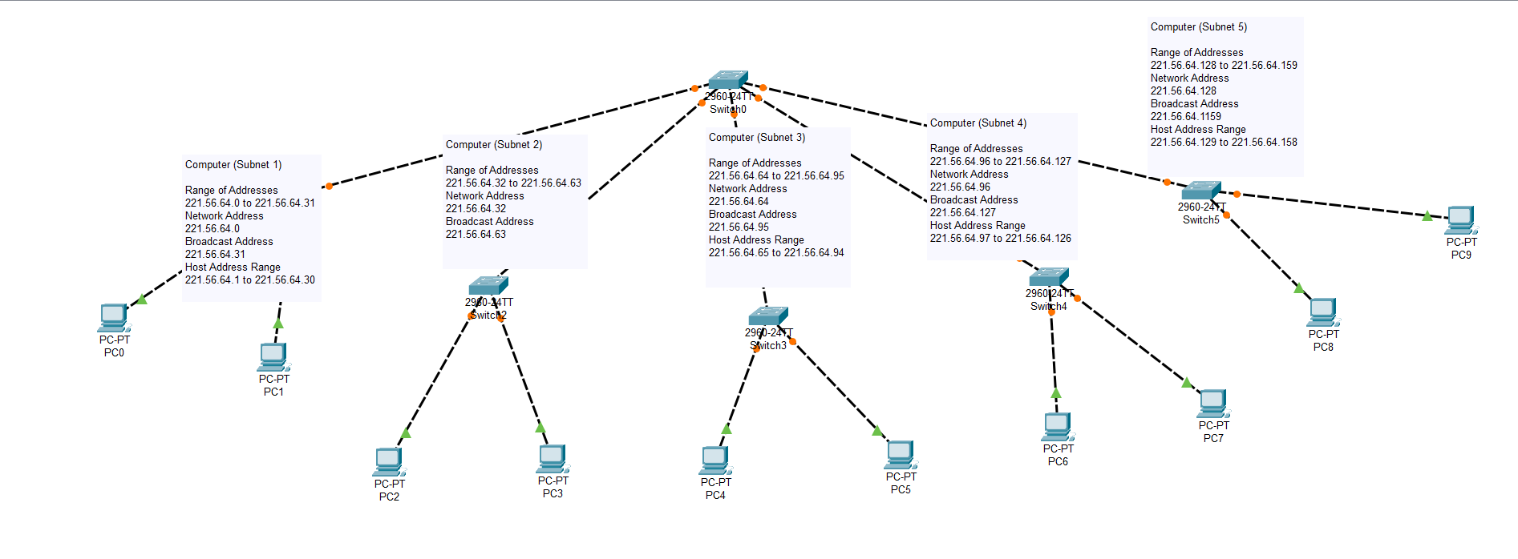

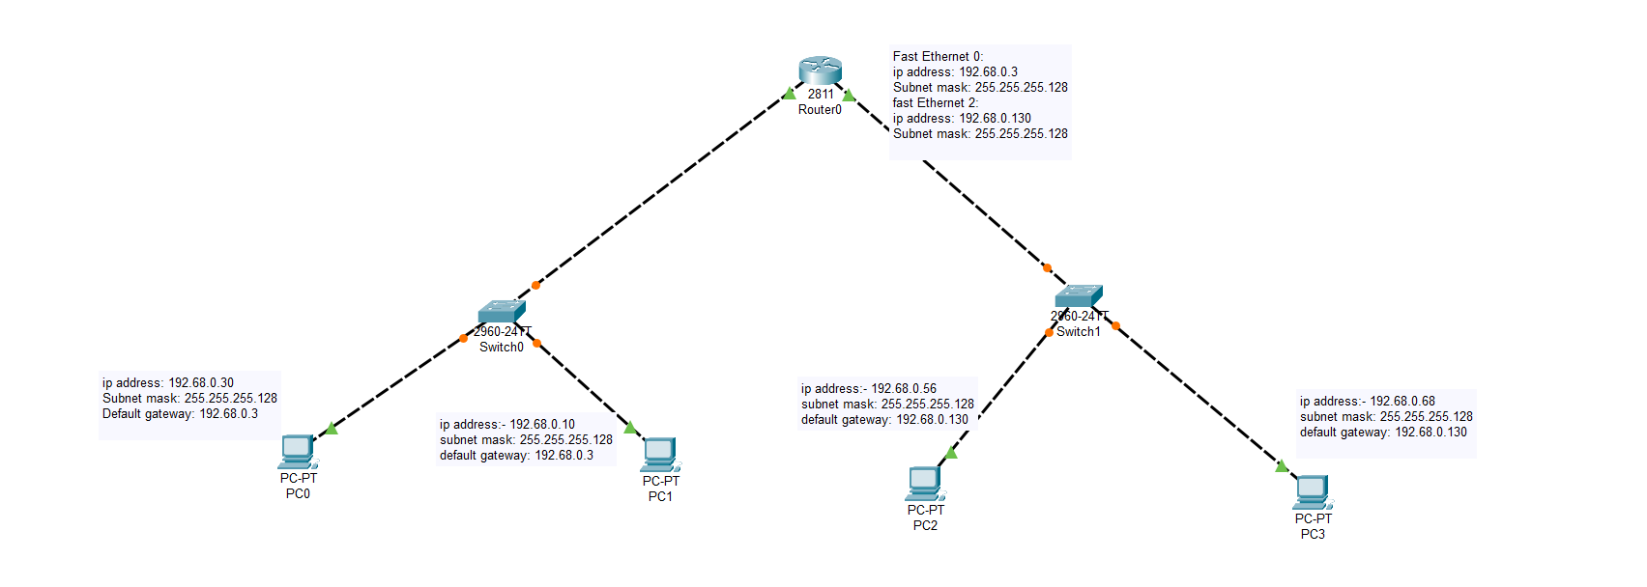

**Configuration of Supernetting**

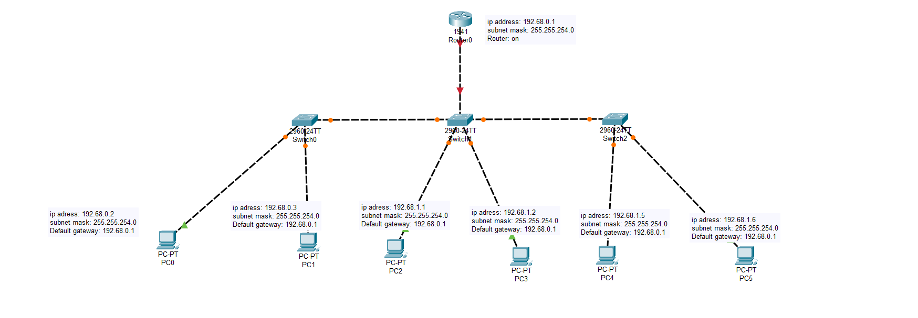

**Packet tracer**

**Conclusion :** In conclusion, subnetting and supernetting are critical techniques in network design and management, each serving unique purposes to optimize IP address utilization and enhance network performance. Subnetting allows for the logical division of a larger network into smaller, manageable sub-networks, leading to efficient IP address allocation, improved performance, enhanced security, and simplified network management. This is particularly useful in environments like the Vishwakarma University case study, where subnetting effectively organizes and manages the network across different departments.

On the other hand, supernetting consolidates multiple smaller networks into a larger network, simplifying routing by reducing the size of routing tables and improving routing efficiency. This technique is particularly beneficial in scenarios requiring route summarization and in expanding networks to accommodate more hosts.

The digital model created in Cisco Packet Tracer further illustrates the practical application of these concepts, providing a visual and interactive representation of how subnetting and supernetting can be implemented in real-world networks. Through this model, the concepts are brought to life, demonstrating their impact on network design and management.